|  |  |  |  |  |
| --- | --- | --- | --- | --- |
| 1)Executive Summary | | | | |
| Project Manager | | Status Date | Phase | |
| *Dr. Clough* | | 10/19/2020 | Week 2 | |
| Project Status Schedule | G | This status report helps us track what we have done for the week. | | |
| Green = Launch On Schedule | Yellow =Tasks Behind Schedule | | | Red = Critical Path Impact |
| Project Document Repository | https://github.com/Sai-Krishna7/FMS-PJ5-Plan.git | | | |

|  |  |  |  |  |
| --- | --- | --- | --- | --- |
| 2) Key Schedule Milestone Tracking from Gantt Chart | | | | |
| Tasks | Target Date | Actual Date | Status (%) | Comments |
| Arrange blocks | 10/26/2020 | 10/19/2020 | 50 |  |
| Tracing letters | 11/2/2020 | 10/19/2020 | 50 |  |
| Tracing patterns | 10/19/2020 | 10/19/2020 | 50 |  |
|  |  |  |  |  |
|  |  |  |  |  |
|  |  |  |  |  |
|  |  |  |  |  |
|  |  |  |  |  |
|  |  |  |  |  |

|  |
| --- |
| 3) Progress from This Week *<should include pending tasks from previous week>* |

* Create the basic GUI for arranging blocks.
* Work on the tracing pattern task.

|  |
| --- |
| 4) Progress Planned for Next Week |

* Work on the tracing letter task.

|  |
| --- |
| 5) Gantt Chart Updated *<add the newest Gantt Chart>* |

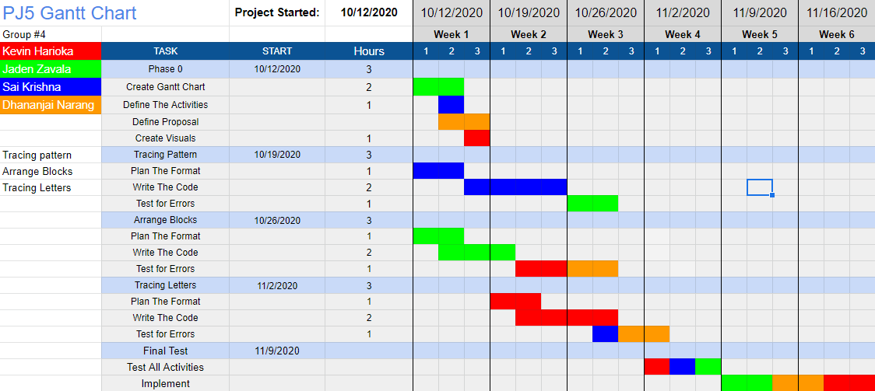

|  |  |  |  |  |  |
| --- | --- | --- | --- | --- | --- |
| 6) Team-Evaluation for the Week | | | | | |
| Team Member Name | Absent | Poor | Fair | Good | Outstanding |
| Jaden Zavala |  |  |  |  | X |
| Kevin Harioka |  |  |  |  | X |
| Sai Deeduvanu |  |  |  |  | X |
| Dhananjai Narang |  |  |  |  | X |